Pokhara University

Level: Bachelor | Semester – Fall | Year : 2009
Programme: BE |  | Full Marks : 100
Course: Electronic Devices |  | Time : 3hrs.

Candidates are required to give their answers in their own words as far as practicable.
The figures in the margin indicate full marks.

Attempt all the questions.

1. | - Describe the characteristics of non-linear elements. How a diode is modeled in piecewise linear model? Explain with diagram.  - What is barrier potential in PN junction diode? Describe and discriminate Zener versus avalanche breakdown. | 8  7
2. | - What is diffusion capacitance? Show that diffusion capacitance is proportional to the current I.  - Following circuit contains a Zener regulator with V_{Z} =8V.  - Determine V_{L}, I_{L}, I_{Z}, and I_{R} for the following circuit if R_{L}=200Ω.  - Repeat part (i) if R_{L}=500 Ω.  - Find the value of R_{L} that will establish maximum power conditions for the Zener diode.  - Find the minimum value of load resistance that ensures the Zener diode in the “ON” state. | 7  8
3. | - Draw DC load line and locate the operating point of the following BJT circuit. 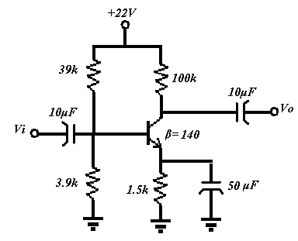  - Explain input and output characteristics of common emitter configuration of transistor. Compare CB and CE configuration of transistor. | 7  8
4. | - The transistor shown in figure has the following h parameter values:h_{ie}=1600Ω, h_{fe}=80,h_{re}=2*10⁻⁴,h_{oe}=20µS.Find Z_{i} ,Zin(stage), A_{v}, 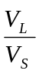 and Z_{o}(stage).  +  -  Vs  C1  C  10v  RE  680 ohm  RL  15K  RS  600 ohm  R2  4.7K  R1  27K  Rc  3.3K  V_{L}  V_{L} | 8
 | What will be the effect on voltage gain if R_{E} = 680Ω is unbypassed?  - Draw small signal r_{e} equivalent model for the following BJT circuit and determine input impedance, output impedance, and voltage gain. Also explain about phase relationship between input and the output waveform. 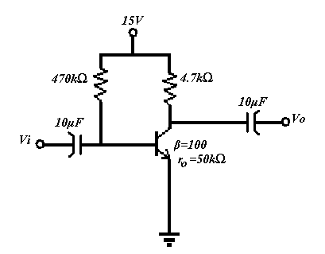  Input wave is sinusoid with V_{inpeak}>V_{B} | 7
5. | - Explain the construction and working of n-channel JFET with its drain and transfer characteristic.  - The operating points for the following FET configuration are defined by V_{GSQ}=-3.6V and I_{DQ}=2mA, with I_{DSS}=12mA and V_{P}=-6V. The value of output admittance is 25μS. Determine (i) g_{m} (ii) r_{d} (iii) Z_{i} (iv) Z_{o} (v) A_{v}. The notations have usual meaning. 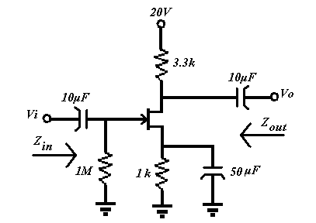 | 8  7
6. | - Explain full wave bridge rectifier with input and output waveforms and derive the expression for (i) output dc voltage, (ii) rms value of output signal, (iii) ripple factor.  - Draw the output waveform for the following clipper circuits when Vi is applied to its input terminals. 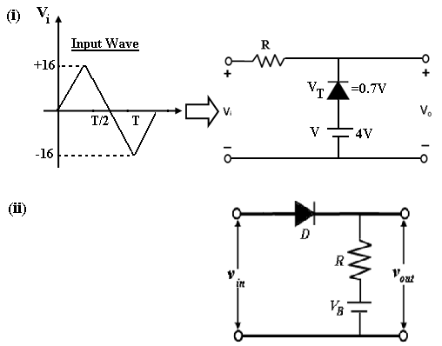  Input wave is sinusoid with V_{inpeak}>V_{B} | 8  7
7. | Write short notes on (Any Two)  - High frequency t-model  - Stability factor for self bias circuit  - EMOSFET | 5×2

